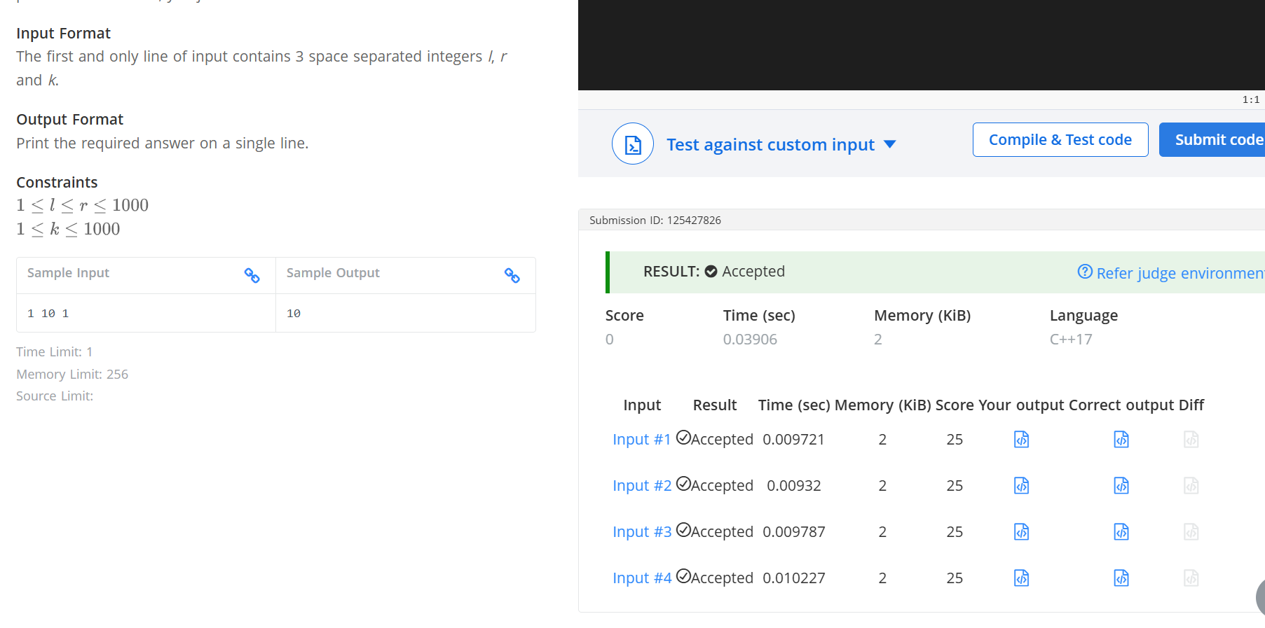
Q Count Divisors
#include <iostream>
using namespace std;
int main() {
int l,r,k;
cin>>l>>r>>k;
int count =0;
for(int i=l;i<=r;i++){
if (i%k==0){
count++;
}
}
cout<<count;
return 0;
}

